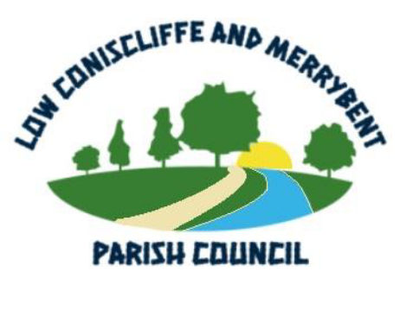
LOW CONISCLIFFE AND MERRYBENT PARISH COUNCIL

NOTICE is, hereby, given of the next meeting of the Low Coniscliffe and Merrybent Parish Council, to be held at St Edwins Church Hall, High Coniscliffe on Tuesday, 03 November 2026 commencing 7.00 pm, for the purpose of transacting the business listed on the AGENDA below:

PUBLIC PARTICIPATION

7.00 - 7.15 pm

A 15 minute discussion period for members of the public to raise questions from the items on the Agenda.

AGENDA

01 Apologies for Absence

02 Declaration of Interests

03 Minutes of the Parish Council Meeting held Tuesday, 15 September 2026
(To be adopted and signed)

04 Matters Arising from Previous Meeting(s)

Coniscliffe Park North Development
Coniscliffe Park South Development

05 Finance and Accounts

06 Parish Matters and Local Maintenance

07 Planning Applications and Decisions

08 Highways

09 Correspondence

10 Information from Meetings Attended

11 Any Other Business

12 Date of Next Meeting

Members of the public should contact the Parish Clerk if they have any matters to raise.

Email: heathertheclerk@gmail.com

Website: www.lowconiscliffeandmerrybentpc.org.uk

